API DOCUMENTATION

API was tested using POSTMAN

- Registration API. “https://localhost:44370/api/auth/register”
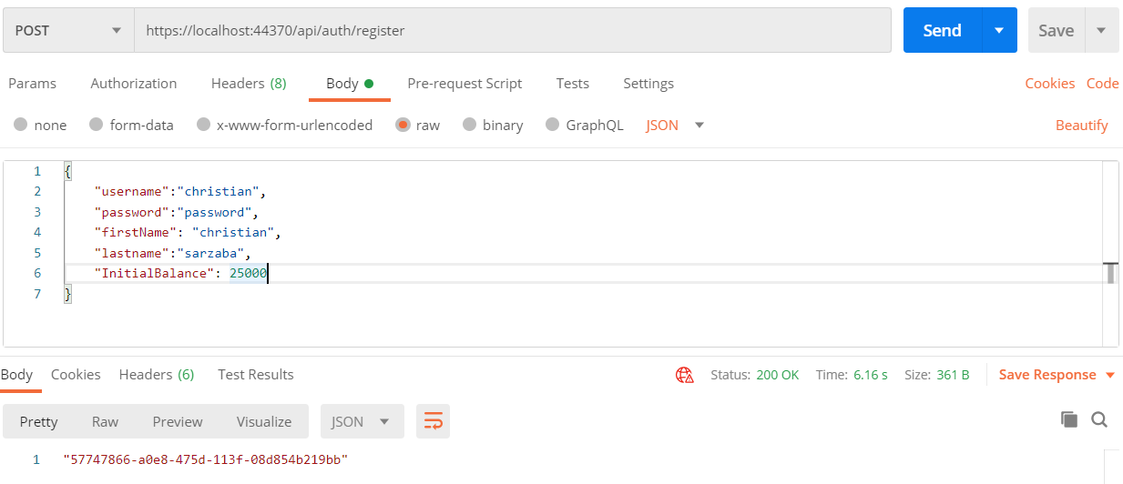

Input Field:
*username, *password, *firstname, *lastname, middlename, initialbalance

Output Value:
AccountID - GUID

2) Login API. “https://localhost:44370/api/auth/login”
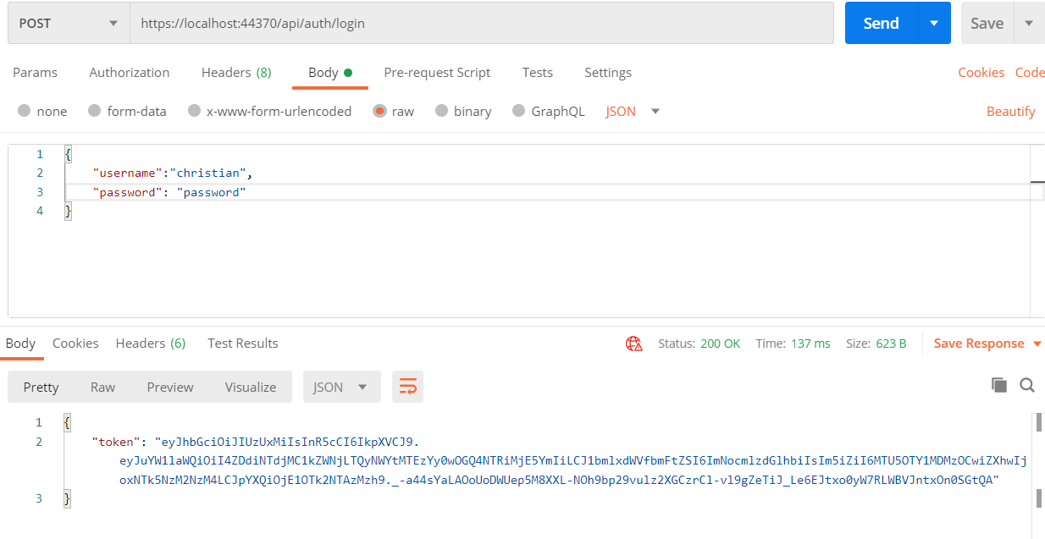

Input Field:
*username, *password

Output Value:
Token - JSON WEB TOKEN (JWT)

- Transfer Money. “https://localhost:44370/api/user/transfer”
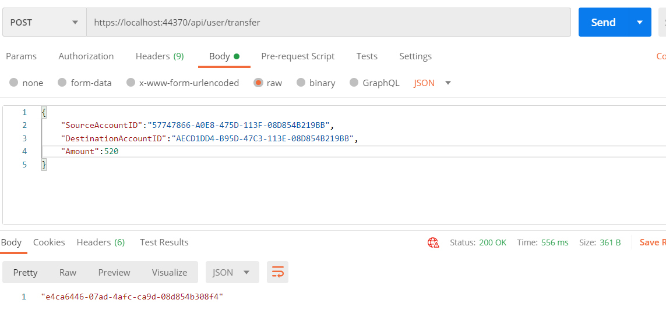

Input Field:
*SourceAccountID, *DestinationAccountID, *Amount

Output Value:
Transaction ID - GUID

NOTE:
Required to use token when access Api/User

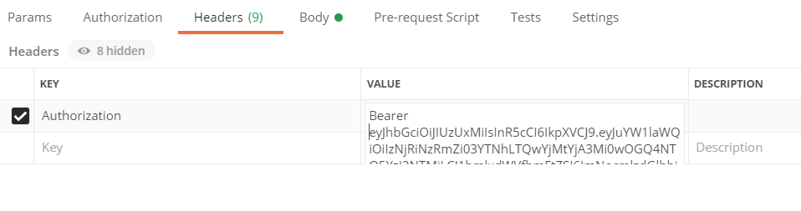
Headers

Key:
Authorization

Value:
Bearer “TOKEN VALUE”

